

User Guide: Extranet

Prepared by Bhattacharjee, Naba
Date: 20/08/2019

Contents
1 Revision History 3
2 Abbreviation 3
3 Introduction 4
4 User Instructions 4
5 Troubleshooting 6

Revision History
 | Date | Description | Version | Modified By | Reviewed By | Remarks
1 |  | Initial Draft | 0.1

Abbreviation

DI | Deployment Instructions

Introduction

This document will help the end users to accept the request and redeem the invite send as an email from Telford and Wrekin SharePoint site.

User Instructions

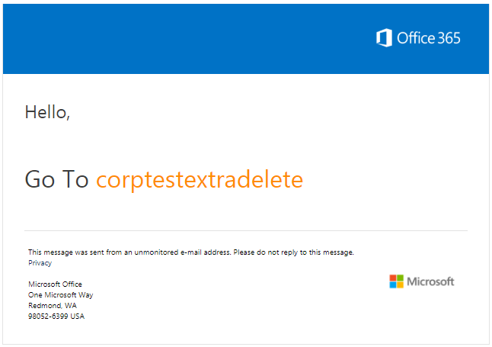  ( if you have taw.org.uk account,login straight away)  If you don’t have Office 365 account, click Create one  Click Name from your email | 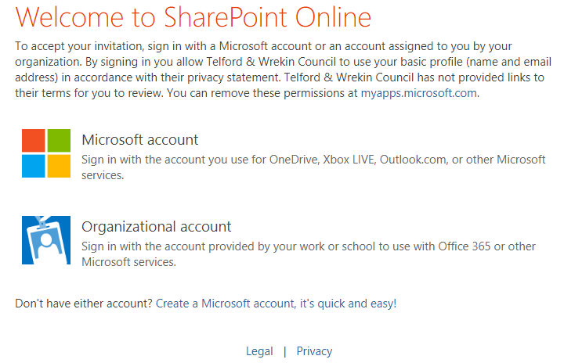  Click on Organisation account
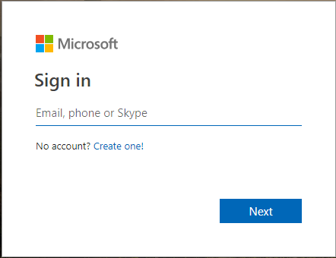 | Type your organisational email address  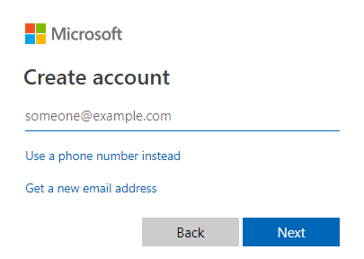
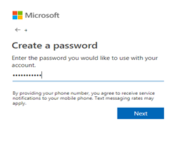  Add a password(does not have to be your org password) | 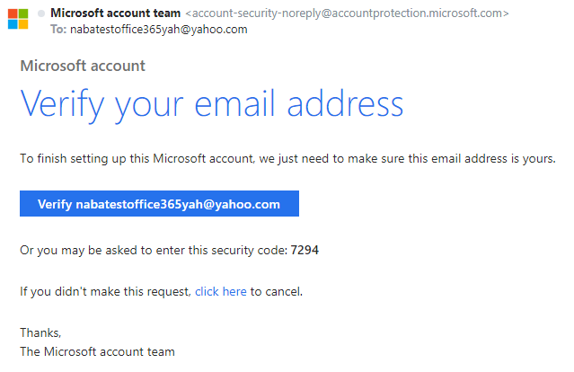  Verification email with code
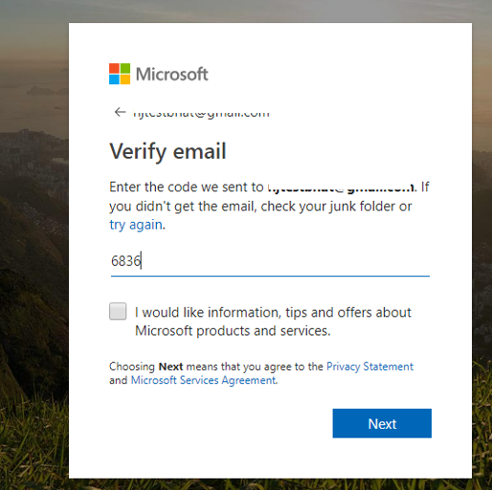  Type the code you received in the previous step | 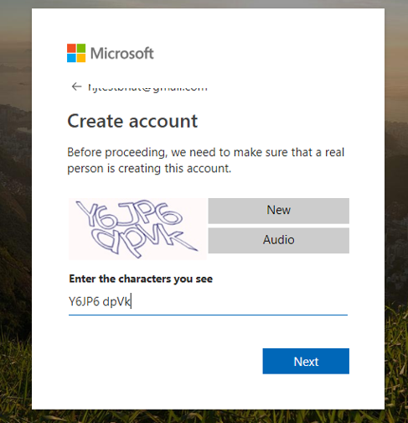  Sometimes it asks for captcha code as well
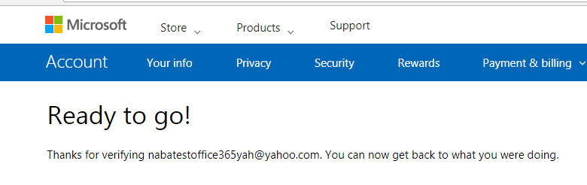

Troubleshooting
There are certain issues which gets triggered during the process of authentication.

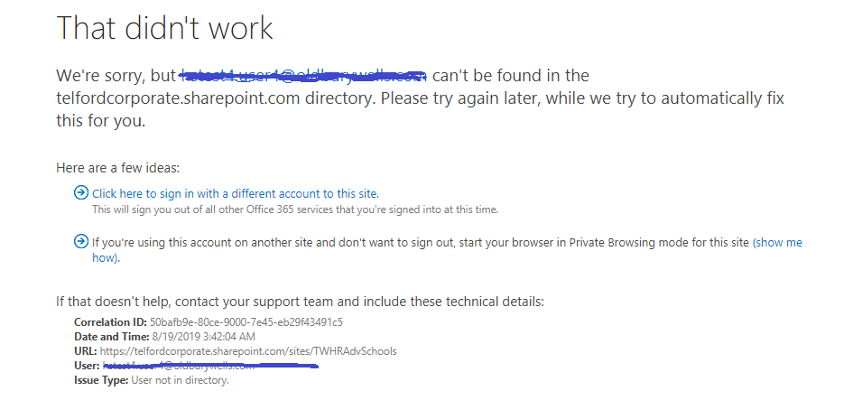

If you get the above message, please type “portal.office.com” and hit enter.
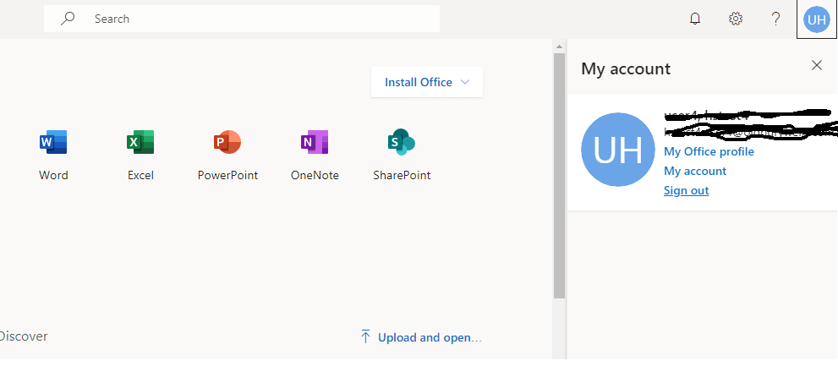
Click
Sign Out

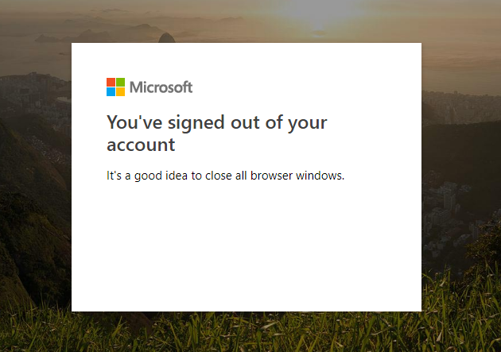

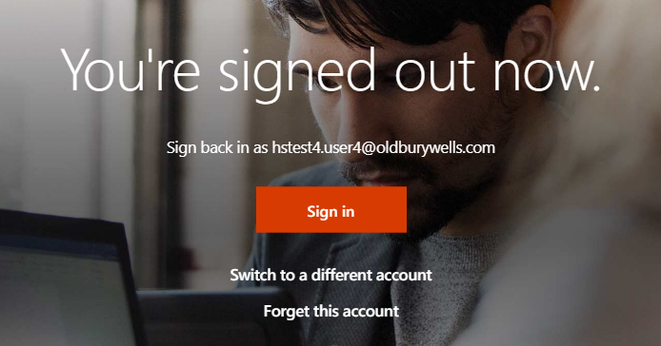
Click forget this account

Then try putting the URL in the address Bar and press enter; next screen put your email address and click next for password.
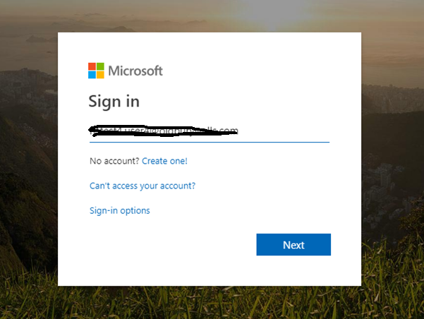
Enter the email id where the invite was sent.

